# WATER IMPURITY ALERT SYSTEM

A Project report submitted in partial fulfillment of the requirements for the award of degree of

### BACHELOR OF TECHNOLOGY

In

### ELECTRONICS AND COMMUNICATION ENGINEERING

By

### A.K.SRAVANTH (121710408003) K.YOGESH (121710408023) M.SHALINI (121710408028) S.BHARATH (121710408041)



Under the esteemed guidance of

Internal Guide Project Guide

### Mr. UDAYA KUMAR Mr. V RAJ KUMAR

Associate professor Assistantprofessor

Department of ECE Department of EEE

GITAM University GITAM University

**DEPARTMENT OF ELECTRONICS AND COMMUNICATION ENGINEERING GITAM INSTITUTE OF TECHNOLOGY**

**GITAM UNIVERSITY, VISAKHAPATNAM ANDHRA PRADESH, INDIA**

**2020-2021**

**DEPARTMENT OF ELECTRONICS AND COMMUNICATION ENGINEERING GITAM INSTITUTE OF TECHNOLOGY**

**GITAM UNIVERSITY, VISAKHAPATNAM ANDHRA PRADESH, INDIA**

**2020-2021**



**CERTIFICATE**

This is to certify that the project work entitled **“ Water Impurity Alert System ”** is a Bonafide work done by **A.K.Sravanth, K.Yogesh, M.Shalini , S.Bharath ,**with **Regd.No: 121710408003, 121710408023, 121710408028, 121710408041,** submitted in partial fulfillment of the requirements for the award of **Bachelor** **of Technology** in **Department of Electronics and Communication Engineering, GITAM University**, Visakhapatnam during the academic year 2020-2021.

### Mr. B. Udaya Kumar, (PhD) Dr. V.Y.Jayasree, (PhD)

Associate professor Professor-HOD

Dept. of ECE Dept. of ECE

GITAM University GITAM University

Visakhapatnam Visakhapatnam

# Acknowledgements

The success in the project would not have been possible by timely help and guidance by many people. I wish to express my sincere gratitude to all those, who have helped and guided me for the completion of the project.

I am deeply indebted to my supervisor **Mr. V Raj Kumar, Assistant****Professor, EEE Department, GITAM institute of technology, GITAM University**, for his excellent guidance and constant encouragement throughout the project work. It was an indeed pleasant and challenging experience to work under his valuable guidance.

I am very much gratified to **Mr. Udaya Kumar, Associate Professor, Project coordinator, ECE Department, GITAM institute of technology, GITAM University**, for his constant and valuable guidance in completion of my project work and I wish to express my deepest gratitude for his valuable advice, personal attention, and continuous encouragement throughout my master program.

I express my deep sense of gratitude and respect to our beloved Head of the Department, **Dr. V Y Jayasree, ECE Department, GITAM Institute of technology, GITAM University** for her valuable guidance and cooperation throughout my project work.

I express my sincere gratitude to **Prof. C Dharma Raj, Principle of GIT, GITAM University, Visakhapatnam** for his great support and providing facilities to accomplish my project successfully.

Last but not least I express my heartfelt gratitude to my family members, colleagues, friends and well-wishers for their direct or indirect help.

#### A.K.SRAVANTH (121710408003)

#### K.YOGESH (121710408023)

#### M.SHALINI (121710408028)

#### S.BHARATH (121710408041)

# Declaration

I, hereby declare that the project entitled “Water Impurity Alert System” work carried out and written by my group under the esteemed guidance of **Mr. B. Udaya Kumar**, Associate professor in Department of Electronics and Communication Engineering, GITAM Institute of Technology, GITAM University, Visakhapatnam, and **Mr. V Raj Kumar,** AssistantProfessor, EEE Department, GITAM institute of technology, GITAM University, Visakhapatnam.

The matter embodied in this dissertation report has not been submitted by me for the award of any other degree. Further the technical details furnished in various chapters in this thesis are purely relevant to the above project and there is no deviation from the theoretical and practical point of view with respect to the design, development, simulation, implementation and testing. If the information furnished in the various chapters is not relevant to the topic and if any mistakes happen to be found in the thesis, I am responsible to give proper explanation and make necessary corrections.

Place: Visakhapatnam **A.K.Sravanth**

Date : Regd No: 121710408003

**Contents**

1. **Abstract** 1
2. **Introduction** 
   1. Aim of the project 2
   2. Motivation of the project 2
   3. Literature Survey 2

### Hardware Components

* 1. Arduino UNO 3

ESP 8266 Wi-Fi Module 4

**Sensors**

i) Turbidity Sensor 5

ii) Ultrasonic Sensor 6

### Software & Code 7-10

### Results 11

### Conclusion 12

B-Tech Project Report Water Impurity Alert System

# CHAPTER 1

## ABSTRACT

One of the main reasons why people get health problem is impure water in overhead water tank. It will not be cleaned regularly which leads to impurity of water present in tank. Hence it is the less concerned threat in any house. As that water is used for all basic purpose, people get affected by impure water easily. Therefore we intend to send an alert whenever the water in overhead tank is impure using turbidity sensor.

Turbidity sensors measure the amount of light that is scattered by the suspended solids in water. As the amount of total suspended solids in water increases, the water’s turbidity level increases. In order to stop the water level to the level of sensing turbidity sensor we are intended to build automatic motor level controller with ultrasonic sensor which controls the water pump.

Using turbidity sensor if impurities present in water increase an alert will be sent either using blynk app or thing speak website. From this project, we tend to reduce many health issues by regular cleaning of overhead tank.

GIT, GITAM UNIVERSITY 1

B-Tech Project Report Water Impurity Alert System

# CHAPTER 2

### AIM OF THE PROJECT

The main aim of this project is to monitor the water in overhead tank.

* + 1. Monitoring the quality of water in overhead tank.
    2. Designed a system for detecting the data using Arduino UNO R3 Hardware board, Sensors and ESP8266 Wi-Fi Module.
    3. Designed a monitoring section for retrieving the data and sending an alert to the user when the water is impure.

### MOTIVATION OF THE PROJECT

Continuous monitoring of the water in overhead tank reduces the health problems occurred by the impurities which were present in tank. In general because of busy schedule one do not tend to clean the overhead tank time to time, As water is the essential need in day to day life, there are many chances of one getting health problems due to impurities present in tank, so if an alert is sent to the user whenever the tank turns dirty the problem can be solved.

### LITERATURE SURVEY

To fulfill the objectives of the Project, understanding the concept and applications of several components such as Turbidity Sensors and Arduino. Several websites and books were referred. Besides these books, some journals are also referred for different technologies used in the project. Literature Survey started with sensors. Sensors are needed to convert a wide range of physical parameters into electrical signals. In the relationship between the history of automation and sensors, it appears that a sensor-technology of automation and sensors, it appears that a sensor-technology lag still exists. This can only be overcome with the concept of integrated sensors.

GIT, GITAM UNIVERSITY 2

B-Tech Project Report Water Impurity Alert System

# CHAPTER 3

### 

### HARDWARE COMPONENTS

### 1. ARDUINO UNO

### The Arduino Uno is an [open-source](https://en.wikipedia.org/wiki/Open-source) [microcontroller board](https://en.wikipedia.org/wiki/Microcontroller_board) based on the [Microchip](https://en.wikipedia.org/wiki/Microchip_Technology) [ATmega328P](https://en.wikipedia.org/wiki/ATmega328P) microcontroller and developed by [Arduino.cc](https://en.wikipedia.org/wiki/Arduino). The board is equipped with sets of digital and analog [input/output](https://en.wikipedia.org/wiki/Input/output) (I/O) pins that may be interfaced to various [expansion boards](https://en.wikipedia.org/wiki/Expansion_board) (shields) and other circuits. The board has 14 digital I/O pins (six capable of [PWM](https://en.wikipedia.org/wiki/Pulse-width_modulation) output), 6 analog I/O pins, and is programmable with the [Arduino IDE](https://en.wikipedia.org/wiki/Arduino#Software) (Integrated Development Environment), via a type B [USB cable](https://en.wikipedia.org/wiki/USB_cable). It can be powered by the USB cable or by an external [9-volt battery](https://en.wikipedia.org/wiki/9-volt_battery), though it accepts voltages between 7 and 20 volts. It is similar to the [Arduino Nano](https://en.wikipedia.org/wiki/Arduino_Nano) and Leonardo. The hardware reference design is distributed under a [Creative Commons](https://en.wikipedia.org/wiki/Creative_Commons) Attribution Share-Alike 2.5 license and is available on the Arduino website. Layout and production files for some versions of the hardware are also available.

### The word "Uno" means "one" in [Italian](https://en.wikipedia.org/wiki/Italian_language) and was chosen to mark the initial release of [Arduino Software](https://en.wikipedia.org/wiki/Arduino_Software). The Uno board is the first in a series of USB-based Arduino boards; it and version 1.0 of the Arduino [IDE](https://en.wikipedia.org/wiki/Integrated_development_environment) were the reference versions of Arduino, which have now evolved to newer releases. The ATmega328 on the board comes preprogrammed with a [boot loader](https://en.wikipedia.org/wiki/Bootloader) that allows uploading new code to it without the use of an external hardware programmer.

While the Uno communicates using the original STK500 protocol, it differs from all preceding boards in that it does not use the FTDI USB-to-serial driver chip. Instead, it uses the Atmega16U2 (Atmega8U2 up to version R2) programmed as a [USB-to-serial converter](https://en.wikipedia.org/wiki/USB-to-serial_converter).

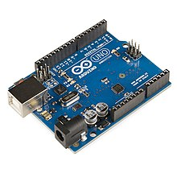

### Arduino Uno Module

GIT, GITAM UNIVERSITY 3

B-Tech Project Report Water Impurity Alert System

### 2. ESP 8266 Wi-Fi Module

The ESP8266 is a low-cost [Wi-Fi](https://en.wikipedia.org/wiki/Wi-Fi) microchip, with a full [TCP/IP stack](https://en.wikipedia.org/wiki/TCP/IP_stack) and [microcontroller](https://en.wikipedia.org/wiki/Microcontroller) capability, produced by [Espressif Systems](https://en.wikipedia.org/w/index.php?title=Espressif_Systems&action=edit&redlink=1) in Shanghai, China.

The chip first came to the attention of Western [makers](https://en.wikipedia.org/wiki/Maker_culture) in August 2014 with the ESP-01 module, made by a third-party manufacturer Ai-Thinker. This small module allows microcontrollers to connect to a Wi-Fi network and make simple TCP/IP connections using [Hayes](https://en.wikipedia.org/wiki/Hayes_command_set)-style commands. However, at first there was almost no English-language documentation on the chip and the commands it accepted. The very low price and the fact that there were very few external components on the module, which suggested that it could eventually be very inexpensive in volume, attracted many hackers to explore the module, the chip, and the software on it, as well as to translate the Chinese documentation.[[3]](https://en.wikipedia.org/wiki/ESP8266#cite_note-3)

The ESP8285 is an ESP8266 with 1 MiB of built-in flash, allowing the building of single-chip devices capable of connecting to Wi-Fi.

The successors to these microcontroller chips are the [ESP32](https://en.wikipedia.org/wiki/ESP32) family of chips, including the pin-compatible ESP32-C3.

In October 2014, Espressif Systems released a [software development kit](https://en.wikipedia.org/wiki/Software_development_kit) (SDK) for programming the chip directly, which removed the need for a separate microcontroller. Since then, there have been many official SDK releases from Espressif; Espressif maintains two versions of the SDK — one that is based on [FreeRTOS](https://en.wikipedia.org/wiki/FreeRTOS) and the other based on callbacks.

An alternative to Espressif's official SDK is the open-source ESP-Open-SDKthat is based on the [GNU Compiler Collection](https://en.wikipedia.org/wiki/GNU_Compiler_Collection) (GCC) tool chain, maintained by Max Filippov. Another alternative is the "Unofficial Development Kit" by Mikhail Grigorev.

### 300px-ESP-01.jpg

ESP 8266 Wi-Fi Module

GIT, GITAM UNIVERSITY 4

B-Tech Project Report Water Impurity Alert System

#### 3. SENSORS

#### TURBIDITY SENSOR

Turbidity is the cloudiness or [haziness](https://en.wikipedia.org/wiki/Haze) of a [fluid](https://en.wikipedia.org/wiki/Fluid) caused by large numbers of individual [particles](https://en.wikipedia.org/wiki/Particle_(ecology)) that are generally invisible to the [naked eye](https://en.wikipedia.org/wiki/Naked_eye), similar to [smoke](https://en.wikipedia.org/wiki/Smoke) in [air](https://en.wikipedia.org/wiki/Air). The measurement of turbidity is a key test of [water quality](https://en.wikipedia.org/wiki/Water_quality).

[Fluids](https://en.wikipedia.org/wiki/Fluids) can contain suspended solid matter consisting of particles of many different sizes. While some suspended material will be large enough and heavy enough to settle rapidly to the bottom of the container if a liquid sample is left to stand (the [settable solids](https://en.wikipedia.org/wiki/Settling)), very small particles will settle only very slowly or not at all if the sample is regularly agitated or the particles are [colloidal](https://en.wikipedia.org/wiki/Colloid). These small solid particles cause the liquid to appear turbid.

Turbidity (or haze) is also applied to transparent solids such as glass or plastic. In plastic production, haze is defined as the percentage of light that is deflected more than 2.5° from the incoming light direction.

This sensor uses infrared LED for the light source and uses infrared phototransistor to detect how much the amount of light not blocked by the turbid water. The mode of action of this sensor is based on the principle that when light is passed from photodiode to phototransistor in water, the amount of light transmitted through water depends on the amount of other matter suspended in the water. If the amount of other material increases then the amount of light transmitted by the photodiode towards the phototransistor will be reduced because it is blocked by other materials.

**Turbidity of Water (NTU) = (1.873+ (0.518 × Total Suspended Solids (mg/l)))**

**Output Voltage (V) = 0.0008× (Turbidity of Water (NTU)) + 3.9994**

Where,

0.008 is the sensitivity of the sensor

3.994 is the output voltage when the sensor detects 0 NTU

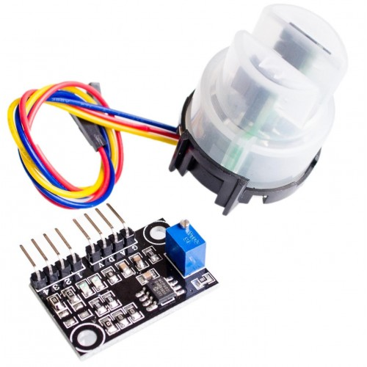

Turbidity Sensor Module

GIT, GITAM UNIVERSITY 5

B-Tech Project Report Water Impurity Alert System

#### ULTRA SONIC SENSOR

Ultrasonic transducers and ultrasonic sensors are devices that generate or sense ultrasound energy. They can be divided into three broad categories: transmitters, receivers and transceivers. Transmitters convert [electrical signals](https://en.wikipedia.org/wiki/Signal_(electrical_engineering)) into [ultrasound](https://en.wikipedia.org/wiki/Ultrasound), receivers convert ultrasound into electrical signals, and transceivers can both transmit and receive ultrasound.

In a similar way to [radar](https://en.wikipedia.org/wiki/Radar) and [sonar](https://en.wikipedia.org/wiki/Sonar), ultrasonic [transducers](https://en.wikipedia.org/wiki/Transducer) are used in systems which evaluate targets by interpreting the reflected signals. For example, by measuring the time between sending a signal and receiving an echo the distance of an object can be calculated. Passive ultrasonic sensors are basically microphones that detect ultrasonic noise that is present under certain conditions.

The design of transducer can vary greatly depending on its use: those used for medical diagnostic purposes, for example the range-finding applications listed above, are generally lower power than those used for the purpose of changing the properties of the liquid medium, or targets immersed in the liquid medium, through chemical, biological or physical (e.g. erosive) effects. The latter class includes ultrasonic probes and ultrasonic baths, which apply ultrasonic energy to agitate particles, clean, erode, or disrupt biological cells, in a wide range of materials

Ultrasound can be used for measuring wind speed and direction ([anemometer](https://en.wikipedia.org/wiki/Anemometer)), tank or channel fluid level, and speed through air or water. For measuring speed or direction, a device uses multiple detectors and calculates the speed from the relative distances to particulates in the air or water. To measure tank or channel [liquid level](https://en.wikipedia.org/wiki/Liquid_level), and also [sea level](https://en.wikipedia.org/wiki/Sea_level) ([tide gauge](https://en.wikipedia.org/wiki/Tide_gauge)), the sensor measures the distance ([ranging](https://en.wikipedia.org/wiki/Ranging)) to the surface of the fluid. Further applications include: [humidifiers](https://en.wikipedia.org/wiki/Humidifier), [sonar](https://en.wikipedia.org/wiki/Sonar), [medical ultrasonography](https://en.wikipedia.org/wiki/Medical_ultrasonography), [burglar alarms](https://en.wikipedia.org/wiki/Burglar_alarms), [non-destructive testing](https://en.wikipedia.org/wiki/Non-destructive_testing) and [wireless charging](https://en.wikipedia.org/wiki/Wireless_charging).

Systems typically use a transducer which generates sound waves in the ultrasonic range, above 18 kHz, by turning electrical energy into sound, then upon receiving the echo turn the sound waves into electrical energy which can be measured and displayed.

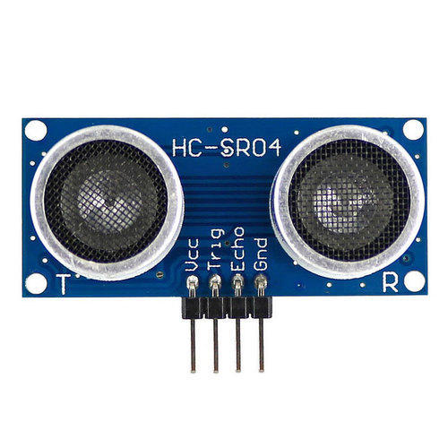

Ultra Sonic Sensor

GIT, GITAM UNIVERSITY 6

B-Tech Project Report Water Impurity Alert System

# CHAPTER 4

**SOFTWARE AND CODE**

Software used: Arduino IDE

Code:

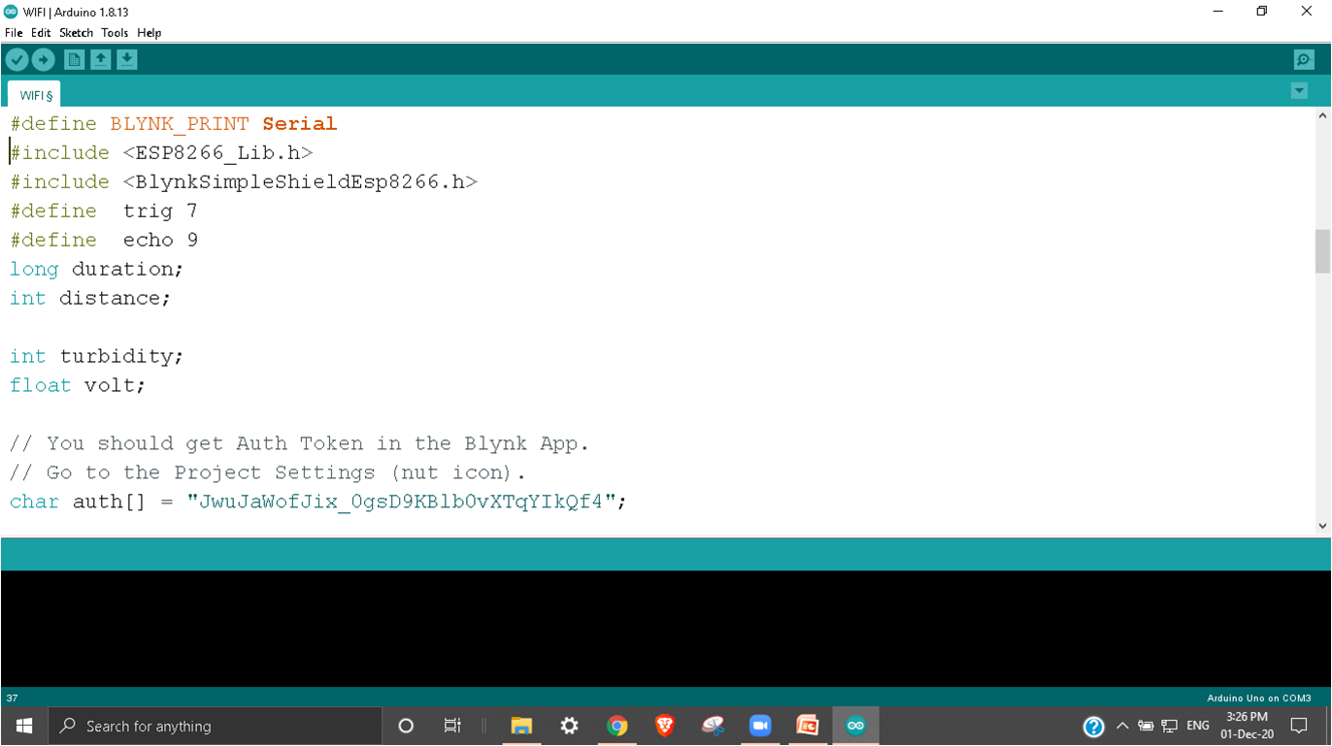

GIT, GITAM UNIVERSITY 7

B-Tech Project Report Water Impurity Alert System

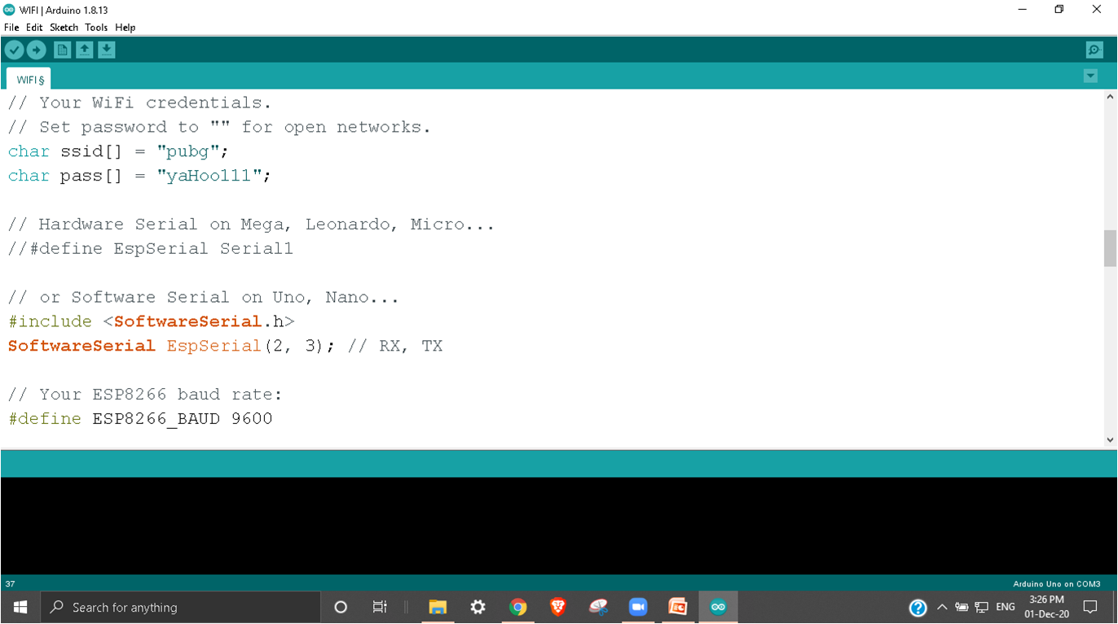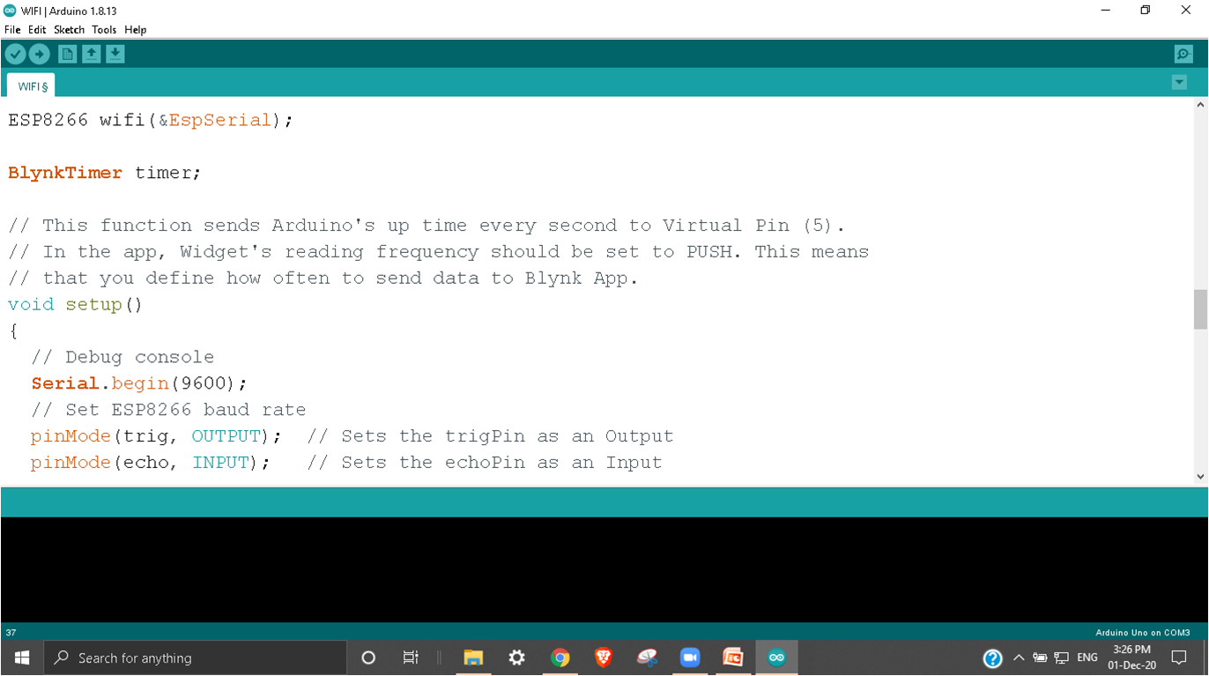

GIT, GITAM UNIVERSITY 8

B-Tech Project Report Water Impurity Alert System

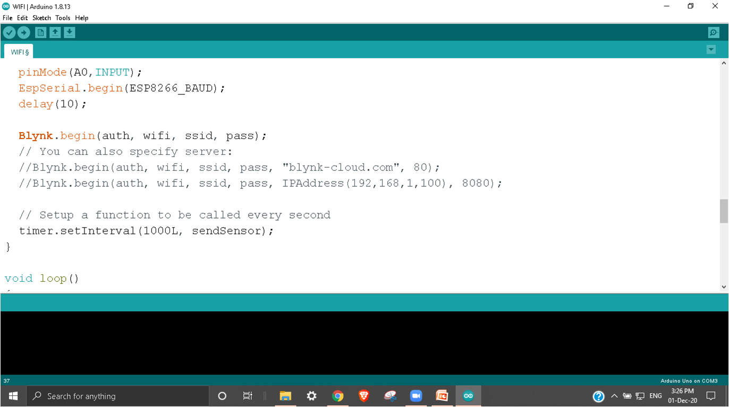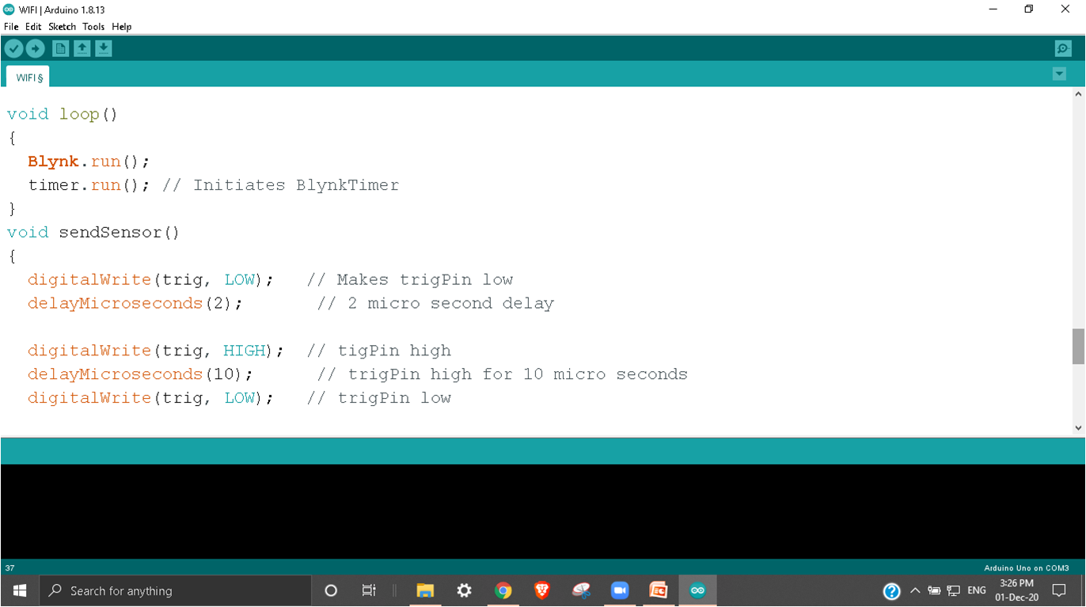

GIT, GITAM UNIVERSITY 9

B-Tech Project Report Water Impurity Alert System

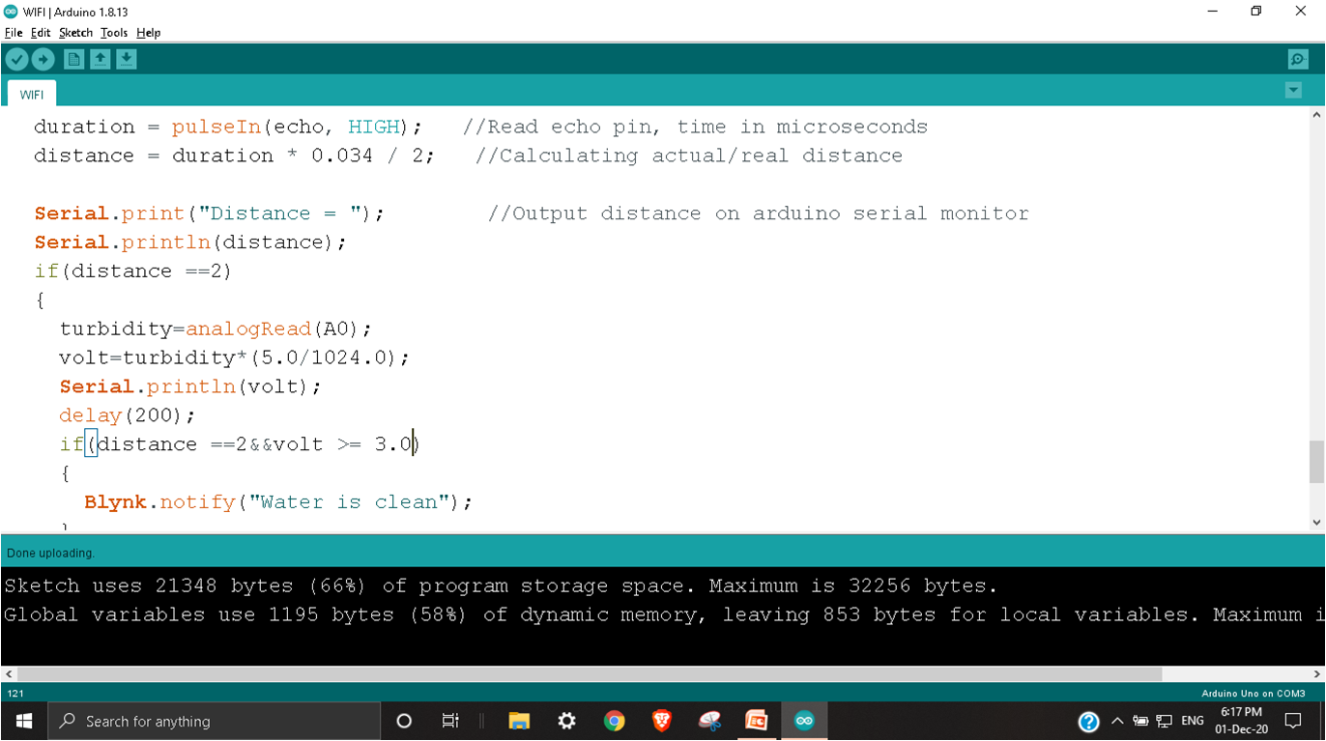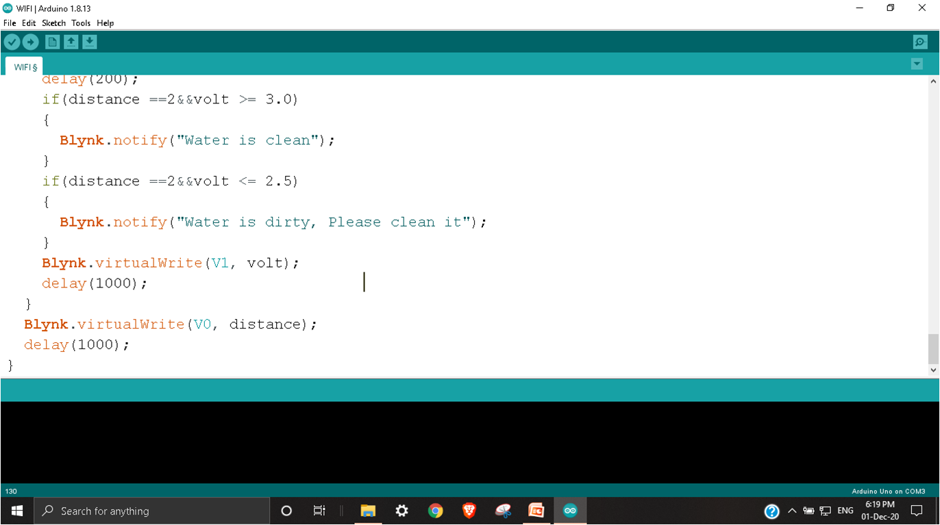

GIT, GITAM UNIVERSITY 10

B-Tech Project Report Water Impurity Alert System

# CHAPTER 5 & 6

# 

# RESULT

# Screenshot (524).pngScreenshot (525).png

GIT, GITAM UNIVERSITY 11

B-Tech Project Report Water Impurity Alert System

# Screenshot (526).pngScreenshot (527).png

**CONCLUTION**

In this way many health problems caused due to germs and impurities present in overhead tank can be reduced.

GIT, GITAM UNIVERSITY 12